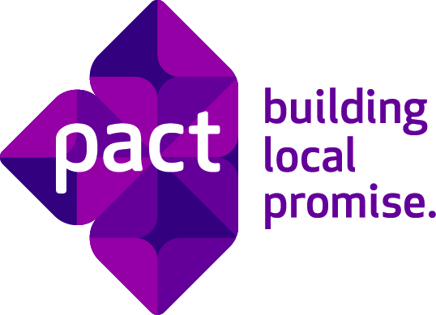
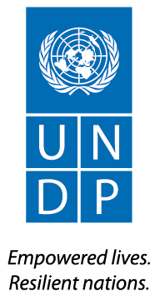
Sustainable Microfinance to
Improve the Livelihoods of the Poor
(MYA/01/004)
STRENGTHEN CIVIL SOCIETY BY MICROFINANCE PROJECT
AWARD NUMBER: AID-486-A-09-00008

Report on:
Self-Reliance Groups Access to Microfinance’s Wholesale Loan
Funded by USAID through UNDP Myanmar and implemented by Pact

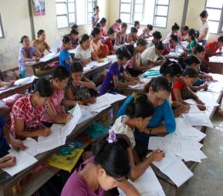
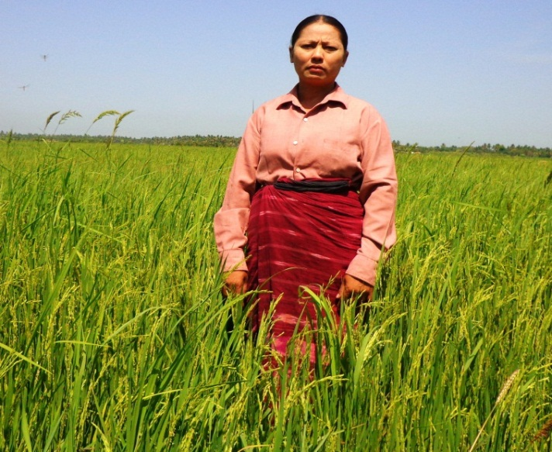
Reporting Period
July-Sep 2013

Reporting Date

Dec 19, 2013
BASIC DATA

Project Title | STRENGTHEN CIVIL SOCIETY BY MICROFINANCE PROJECT
AWARD NUMBER | AID-486-A-09-00008
Duration | 30 Sep 2011 to 30 Sep 2013
Geographical Area | Delta Region Townships:  - Bogale  - Mawgyun  - Labutta
Responsible Organizations | The United Nations Development Program (Myanmar) and PACT Myanmar
Total Project Cost | $2,109,000
Reporting Period | July-Sep 2013 ( Fourth Quarter Report, 2013)

Executive Summary
- Introduction
With fund provided by US Government worth US$ 2,109,000, Pact carries out the “Self-Reliance Groups Access to Microfinance’s Wholesale Loan” program. The program aims to provide wholesale loans to 500 Self-Reliance Groups (SRGs) over a period of two years in three townships – Bogalay, Mawgyun and Laputta – in the Delta Zone in Myanmar.
SRGs were initially introduced into the HDI through a CDRT project in 1997 and an ICDP project in 2003. The most common reason for community members to participate in an SRG is access to credit at a relatively low interest rate under flexible rules and regulations. With an easy and affordable lending plan, SRGs stand out as an attractive option for accessing credit. SRGs work by creating a revolving common fund are composed of their members’ savings, equity provided by UNDP, and interest income generated through lending to its members. However, over time the common fund is generally insufficient to meet the capital requirements of the members as their businesses continue to grow. Therefore, UNDP’s ICDP and PACT jointly initiated the “Self-Reliance Groups Access to Microfinance’s Wholesale Loan” program to address this need for enhanced capital.
Country office of UNDP Myanmar, using funds received from USAID, initiated the program in September 2011 and proceeded to full implementation by January 2012. The program targeted provision of wholesale loans to 500 SRGs by September 2013 in three townships – Bogale, Mawgyun and Labutta – in the Delta Zone. The activities involved in implementing the SRG-Microfinance (MF) linkage program were:
a) Sensitizing SRGs on SRG-MF linkages and wholesale loans (ICDP),
b) Performing Capacity Assessments of the SRGs (ICDP),
c) Providing Capacity Building training to the viable SRGs (ICDP),
d) Collecting loan proposals and loan processing (Pact),
e) Loan delivery (Pact), and
f) Collection of repayment and monitoring of financed activities (Pact).

- Achievements
The program achieved considerable amount of success as of the reporting period. Some key accomplishments include:
- As of September 2013, the project has reached 342 SRGs to provide with wholesale loan.
- Disbursement of wholesale loans worth 154.8 million Kyats ($159,639) to 93 SRGs during the 4th quarter of FY2013 (July-September). Among those, 36 SRGs received first-cycle loans amounting to 32.8 million Kyats; 40 SRGs received second cycle loans amounting to 70 million Kyats; 11 SRGs received third-cycle loans amounting to 31.3 million Kyats; and 6 SRGs received fourth-cycle loans amounting to 20.7 million Kyats;
- Sensitization of 182 SRGs in three townships;
- Field visits to 13 villages and performance of 18 capacity assessments in the reporting period, resulting in identification of 15 SRG as functioning and 3 SRGs as weak
- Conducting capacity building training for 21 SRGs with 42 SRG leaders taking place
- Recruiting 342 SRGs as of the reporting period against target of 500 SRGs, attaining 68.2% of the revised target.
- Reaching an outstanding portfolio of 330.3 million Kyats (US$340,867) at the end of Sep 2013; and
- Maintaining a 100 percent repayment rate for the SRG-MF linkage program.
- Challenges
- Due to the closure of UNDP’s ICDP Project, Pact was unable to have access to enough trained SRGs to meet the program targets.

Program Performance of Wholesale loan provision to SRG
A. Background
SRGs are composed of community members who have a common background, face similar financial constraints and are interested in improving their overall livelihoods. Groups are usually made up of 15-20 people. This small size is often preferable as it allows members to easily build trust and cohesion, meet regularly and manage finances and recordkeeping. Members of SRGs set their own rules, regulations, and procedures. At the center of the group is the common fund, which is set up by the members’ savings and serves as a revolving resource base. Through members’ savings, group income and financial support from ICDP, the common fund provides loans to SRG members.
In 1994, UNDP Myanmar launched the Human Development Initiative (HDI) program in carefully selected geographical areas of Myanmar to address the human development and humanitarian needs of people in those regions in a sustainable manner.

As part of its Human Development Initiative (HDI) in Myanmar, UNDP has implemented two multi-sector community development projects – the Integrated Community Development Project (ICDP) and Community Development for Remote Townships (CDRT) project – to improve the social and economic status of the poor. The project used participatory methodologies to build the capacity of local communities and increase their social capital through Self-Reliance Groups (SRGs) and community-based organizations.

Self-Reliance Groups (SRGs) were initially introduced into the HDI through a CDRT project in 1997 and an ICDP project in 2003. Extensive support and trainings were provided by UNDP through its field staff to the SRGs on basic concepts of group management and developing organizational and social capital. Both the CDRT and ICDP projects established the concept of a Common Fund (CF); which is set up using members’ savings, financial contributions from UNDP, and interest-generated income from loans to members. The CF works as a revolving resource base for an SRG as it provides loans to the members and generates income from the loans. However, sometimes the revolving CF was unable to fulfill the capital requirements of SRG members. This prompted the need for a source that could enhance the capital base so UNDP’s Microfinance Program implemented by PACT (MFP) stepped in as a source of capital.

Following the recommendations from a previous Independent Assessment Mission (IAM), UNDP Myanmar agreed to establish a linkage between its two HDI projects – ICDP and MFP – by providing access to credit to the SRGs from the MFP. It paved the way for SRGs created by ICDP to access wholesale lending from MFP to supplement their common fund and meet the members’ demands for higher working capitals as their businesses grew. The SRG-MF linkage was initiated by UNDP for the first time in 2009 when SRGs from the Shan Zone were first chosen for wholesale loans as they were found to be the most functional among all the SRGs in three regions – Delta, Dry and Shan.
USAID provided fund assistance worth $2,109,000 to UNDP to undertake the “Self-Reliance Groups Access to Microfinance’s Wholesale Loan” program with an aim to expand wholesale loans to 500 SRGs in three townships in the Delta Zone.

B. Goal and Objectives
The main goal of the “Self-Reliance Groups Access to Microfinance’s Wholesale Loan” program was to link two HDI projects – Microfinance Project (MFP) and Integrated Community Development Project (ICDP) – to provide the SRGs access to MF loans in HDI townships where MFP and ICDP were working together. MFP undertook the following objectives to achieve the goal:
Objective 1: To enhance the capacity of viable SRGs in loan fund management and bookkeeping through specialized training prior to loan delivery.
Objective 2: Provide wholesale loans to the SRGs to support microenterprise ventures of their members.
C. Methodology
The two projects collaborated to establish criteria and terms for the new “wholesale loan” product (Annex A), developed by MFP, and agreed on a capacity assessment tool that would be used in assessing the SRGs.
Wholesale loans are given to viable SRGs as a group loan, not as an individual loan, and the SRG leaders decide on how to lend it to their members. The loan size and pay-back period are flexible (maximum 12 months), with a mutually agreed repayment schedule. Subsequent loans depend on the performance of the previous loan taken from the MFP. Leaders of the SRG act as the third-party guarantor of the group loan from the MFP and collaborate with MFP Loan Monitors and Training Officers in implementing of the program by performing a capacity assessment, providing capacity building training, maintaining credit discipline and setting up a repayment schedule.

D. Performance and Deliveries
The three townships selected for the intervention had 1,062 Self-Reliance Groups identified by ICDP . Out of these, ICDP was supposed to target 500 to receive capacity development and then be assessed jointly with MFP before becoming eligible for wholesale loans. MFP started with a sensitization meeting for SRG representatives where the concept of linkage with SRGs and the methodology of the wholesale loan were discussed.
After the sensitization meeting with SRGs, a Joint Capacity Assessment was conducted by ex-ICDP staff contracted by UNDP and MFP staff to verify the viability of the SRGs. The SRG capacity assessment form is attached in ANNEX (B). Capacity assessments took the following criteria into account:
- Managing capacity of loans, including re-lending and recovery rates
- Status of savings mobilization
- Keeping of records inclusive of bookkeeping and accounting system
- Leadership status of the SRG
During the reporting period, July-Sep 2013, capacity assessment for eighteen SRGs has been conducted jointly by Pact and ICDP in which 15 SRGs were deemed functioning and three to be weak. Performance of the Joint Capacity Assessment is shown in Table (1). The terms “self-reliant” and “functioning” denote the ability of the SRG to manage its affairs, not its level of financial security.

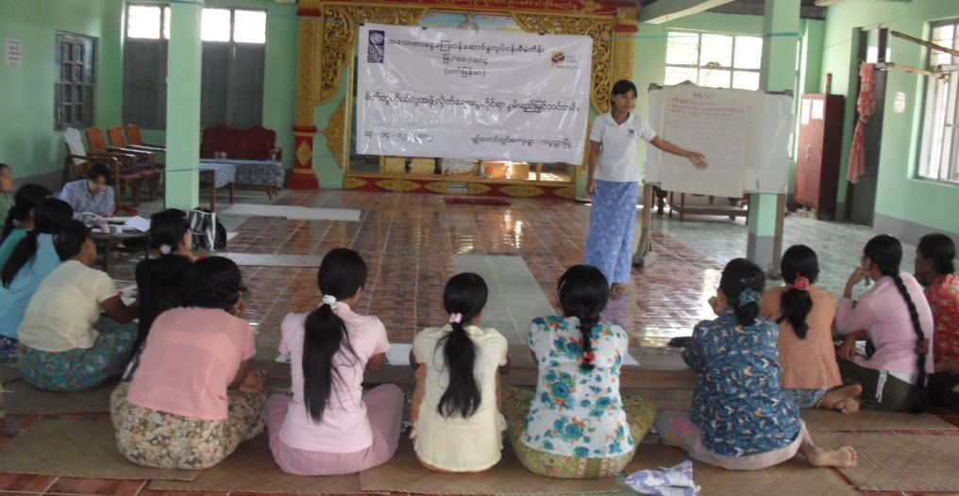
Capacity Building Training: In addition to enhancing the capacity of SRGs that would receive access to wholesale loans, MFP also built up the capacity of both ICDP and MFP project staff. A series of training-cum-workshops and meetings were conducted for the staff to discuss the concept, methodology, and process of SRG-MF linkage program as a whole, convincing them that the program is a necessity to provide capital assistance to the SRGs.
Fig 1. A Capacity building training in Progress

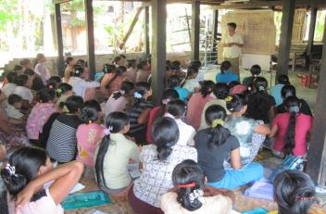
After performing a capacity assessment to identify viable SRGs, PACT provided training on loan management to SRGs which qualified for wholesale loans. Forty two participants from 21 SRGs participated during the reporting period. Training covered cash flow forecasting, feasibility assessment, selecting viable businesses and recordkeeping.

Fig 2. A Capacity Assessment in Progress

First Wholesale Loan Delivery:
The first loan of 1.5 million Kyats ($1,718) was delivered to the SRG, “Inn Gyin May” in the Myit Tan Village of Bogalay Township on 29 December, 2011. With a view to avoiding excessive loan burden, SRG members were allowed to choose only one loan; either a loan from the common fund (CFL) or a wholesale loan (WSL). In the case of Inn Gyin May SRG, it was found that only 2 SRGs member were entitled to WSL. They were successful in their businesses and faced no difficulties in repaying loans in 10 equal bi-weekly installments as per agreed under loan contract. Since then more wholesale loans were provided to viable SRGs.
During the 4th quarter of 2013 (July-Sep), wholesale loans amounting to 154.8 million Kyat have been provided to 93 viable SRGs , 36 SRGs received Ks. 32.8 million for 1st cycle loan, 40 received Ks. 70 million as second cycle, 11 received Ks. 31.3 million as third cycle, and 6 received Ks. 20.7 million as forth cycle. See township wise details in table (3).

Fig. 4 Loan Utilization
In Delta Region, SRG clients are involved in agriculture, fishing and animal husbandry, trading, and services.

E. Accomplishments against Expected Outputs: (Please refer Annex C)
F. Human Resources:
As a new loan product for the Delta Region, a different methodology was utilized to provide the wholesale loans. Separate branches have been set up in each of the three townships to boost the performance and to ensure timely accomplishment of targets. A total of twenty-one (21) employees were assigned at 3 branches in the Delta Region – 3 Branch Managers, 3 Project Accountants, 4 Training Officers, 8 Loan Monitors and 3 Boat Drivers.
G. Implementation Issues:
This combined project demands a lot of time and patience from the field staff from both MFP and ICDP to introduce the new loan product and methodology to the SRGs, the wholesale loan.
The biggest challenge to meeting the project targets in quarters 2-4 of this year has been UNDP’s decision to shut down the ICDP program with outstanding funds and pending targets. Without a stream of identified and trained SRGs flowing from ICDP, Pact has been unable to fully implement its part of the project. In July, Pact and UNDP did agree to a limited re-involvement by former ICDP staff that could have allowed Pact to reach 350 SRGs had it been implemented in a timely manner. UNDP also sent a proposal to USAID to reduce the target from 500 to 350 SRGs.
One of the other major challenges was to convince SRGs that the program was to assist them in fulfilling their capital requirement and that they were being given loans, not grants. It also took time to help them understand that the wholesale loan contract requires a signature by all members of the SRG, regardless of how many of them take the loan. Other issues and challenges cited as of the end of September are as follows;
- As there are 1,062 SRGs in Delta, 342 SRGs received access to credit from MFP and it was learned that the remaining 720 SRGs could be classified as follows:
- 309 SRGs are found to be in defunct stage, which are required to revive again
- 8 SRGs have a very few active members
- 26 SRGs explained that they have enough common fund and no requirement for additional capital
- Weak solidarity was found in 16 SRGs
- 44 SRGs expressed that they do not want wholesale loans
- 80 SRGs are in weak status
- 87 SRGs are having overdue loans
- 11 SRGs stated that they would not like to attend regular meeting
- 136 SRGs were impoosible to contact
- 3 SRGs are in remote areas and could not be reached for the time being
- SRG members could take one loan only, either from common fund or wholesale loans through the group.
- No financial net margin for SRG has been seen in the SRGs which already received wholesale loans; PGMF charges 30% annually and members pay the same rate, no earning for SRG as a group.
- Due to (3) above, SRGs leaders have no interest in taking wholesale loans from PGMF.

H. Lessons Learnt:
- MFP wholesale loans can be a valuable tool to fulfill the need to supplement SRGs’ common funds in order to help increase the capital base of SRGs members who can expand their businesses.
- Capacity building is required for SRGs to link them with formal financial services; especially on record keeping so that SRG leaders can keep track of all financial transactions and the link up with microfinance program as a good solution.
- Collaboration between UNDP and HDI Projects is essential to identify viable SRGs and in the capacity assessment for wholesale lending. Without this link, it is impossible to successfully implement the project with the given budget.
- Wholesale loans are a good support for the SRGs and all SRGs given access to wholesale loan were able to repay on time and took subsequent loans.
- SRGs with strong leadership and with members in viable businesses could be linked with MFP if they are in need of additional capital and willing to borrow.
- Thanks mainly to the experience gained in Shan, SRG wholesale program has been successfully implemented in Delta.
- Allowing SRG members to access both common funds and wholesale loans simultaneously up to a pre-approved limit can help members to better finance their businesses and can create more demand for wholesale loans among current client SRGs and non-client SRGs.

I. Conclusion:

Thanks to the United States Government for providing the fund for this SRG-MF linkage initiative that created a bridge between the SRG and MFP, resulting in a new mechanism to fulfill the capital requirements of SRGs.
The program became a good example for Microfinance practitioners demonstrating that solidarity lending modality and SRG modality could work side by side.

Date: Dec 19, 2013 UNDP/PACT Myanmar
ANNEXES

ANNEX A: Description of Wholesale loan products from MFP for SRGs/CBOs
General Description:

Wholesale loans will be given to the SRGs as a group and the SRGs will take responsibility for the utilization by its individual members and for repayment of the whole loan. Loans will be provided for the SRGs and CBOs organized by the ICDP/CDRT projects, which are in need of additional capital for fulfilling the demand of their members. The SRGs requesting wholesale loans as recommended by the ICDP/CDRT projects will be selected by Pact, based on its selection criteria and the viability of the businesses proposed by the SRGs. The terms and conditions of the wholesale loan are as follows:

Eligibility
• Strong recommendation by the sponsoring UNDP Project (ICDP/CDRT) for the SRG for wholesale loan.
• Only SRGs/CBOs organized and trained by UNDP projects will be eligible to access this wholesale loan.
• Members of the SRGs are well-trained and have passed through the selection criteria by capacity assessment checklist.
• Members of the SRGs have proven track records for managing at least two cycles of own loan activities.
• SRGs must undertake to follow the MFP loan discipline and repayment schedule.

Loan Size
- Loan size will be decided depending on capacity of the SRG and the proposed business.
- Maximum K 1,500,000 per SRG will be allowed in the first cycle.
- Subsequent loan size will depend on the performance of the previous loan taken from MFP.

Loan Terms
- Maximum 12 months with a mutually agreed loan repayment schedule.
- The SRG management committee will be the third party guarantor for the MFP loan to the SRG.
- SRG leadership will collaborate with the MFP Loan Monitors and Field Trainers for successful implementation of the program.

Interest Rate
- Interest rate for wholesale loan is 3% per month (2.5% from 1st April 2012).
- MFP will pay 20% interest on the SRG savings/common fund deposited with the project (15% from 1st Apr 2012).

Repayment
- Bi-weekly/monthly/quarterly/biannual repayments of interest and principal as agreed.
- Settling of the whole outstanding amount before due date will be accepted along with the due interest.

Subsequent loans
- After successful repayment of the current loan, application for the next loan can be made. Usually new loan app

- lications are processed during the last repayment installment period of the previous loan.

TABLES:

Table (1) Delta Region SRGs Capacity Assessment Status during July-Sep 2013
Sr. | Township | Number of Existing SRGs | Targeted SRGs for Year-I & II | No of SRGs Assessed | Status
 |  |  |  |  | Self-reliant | Functioning | Weak
1 | Bogalay | 407 | 185 | 8 |  | 7 | 1
2 | Mawgyun | 301 | 144 | 4 |  | 3 | 1
3 | Laputta | 354 | 171 | 6 |  | 5 | 1
Total |  | 1,062 | 500 | 18 |  | 15 | 3

Table (2) Capacity Building Trainings provided during July-Sep 2013
Sr. No. | Types of Training / Workshop | Number of Training / Workshop Conducted | Number of participants |  |  |  | Training Duration (Days) | Venue (s)
 |  |  | MFP Staff | ICDP Staff | No. of SRG members | Total
1 | Orientation Meeting on SRG Linkage with MF | - | - | - | - | - | -
2 | Workshop on SRG MF linkage (TOT ) (Providing Wholesale Loan to SRGs) | - | - | - | - | - | -
3 | Sensitization Meeting to SRG Leaders | 182 | 21 | 9 | 324 | 354 | 1 | SRGs villages in delta three townships
4 | Capacity Building through Training for SRG Leaders | 21 | 6 | - | 42 | 48 | 1 | Same as above
5 | Planning and Review Workshop on MF Linkage with SRGs | 1 | 6 | 4 |  | 10 | 1 | For Year-II Review and Planning Meeting
6 | ICDP -MF joint Review and Coordination Meetings | 3 | 2 | 2 |  | 4 | 3 | Finalizing for achieving target in within Aug., and Sep., 2013

Table (3) Township-wise loan disbursement and loan outstanding during July-Sep 2013

TSP | Wholesale Loans disbursed in K ‘000 |  |  |  |  |  |  |  |  |  | Outstanding in Ks. ‘000
 | 1st cycle |  | 2nd cycle |  | 3rd cycle |  | 4th cycle |  | Total |  | Total
 | No of SRGs | Amt | No of SRGs | Amt | No of SRGs | Amt | No of SRGs | Amt | No of SRGs | Amt | No of SRGs | Amt
BGL | 15 | 11,400 | 18 | 25,350 | 1 | 1,200 | - | - | 34 | 37,950 | 77 | 71,516
MG | 9 | 11,000 | 7 | 15,100 | 10 | 30,100 | 6 | 20,700 | 32 | 76,900 | 88 | 164,550
LPT | 12 | 10,400 | 15 | 29,600 | - | - | - | - | 27 | 40,000 | 81 | 94,246
 | 36 | 32,800 | 40 | 70,050 | 11 | 31,300 | 6 | 20,700 | 93 | 154,850 | 246 | 330,312

Human Development Initiative program of UNDP in Myanmar
CDRT – Community Development for Remote Townships
ICDP – Integrated Community Development Project
969.24 Kyat per one US Dollar is assumed as quarterly rate by calculating weighted average on loan disbursement
The target has been agreed to reduce to 350 SRGs
$1 =969.24 according to weighted average rate of disbursement during the quarters

